|  |
| --- |
| **Data Structures (CS2001)** |
| Date: Nov’4th 2024 |
| **Course Instructor(s)** |
| Dr. Jawwad A. Shamsi, Dr. Abdul Aziz, Dr. Farrukh Hasan, Ms. Mubashra Fayyaz, Ms. Ayesha Ali, Ms. Rafia Shaikh, Mr. Nouman Rajput |

|  |
| --- |
| **Sessional-II Exam** |
| **Total Time: 1 hour** |
| **Total Points: 30** |
| **Total Questions**: **03** |
|  |
| **Semester:** Fall-2024 |
| **Dept:** CS / AI/ CYS/ SE |

|  |
| --- |
| ____________________________ ______________ _____________________  Student Name Roll No Section Student Signature |

**Do not write below this line**

**Attempt all questions in order. Out of order answers will not be graded.**

*CLO #1: Use & explain concepts related to basic and advanced data structures and describe their usage in terms of common algorithmic operations*

**Question 1: [10 points]**

Write the code to use Quicksort to find the median of an unsorted array without necessarily sorting all the elements. Explain the logic of your code separately.

**[Solution]**

1. Determine the Median Position:
   1. For an array of n elements:
      1. For an odd number of elements: The median index is n / 2.
      2. For an even number of elements: The median is the average of the elements at indices n / 2 - 1 and n / 2.
2. Partitioning:
   1. Choose a pivot element in the array, as in QuickSort, and partition the array around this pivot:
      1. Elements less than the pivot go to its left.
      2. Elements greater than the pivot go to its right.
   2. After partitioning, the pivot is in its correct sorted position in the array.
3. QuickSelect Process:
   1. Check the pivot's index:
      1. If it matches the median index (or indices), we’ve found the median.
      2. If the pivot index is greater than the median index, recursively apply QuickSelect on the left subarray.
      3. If the pivot index is less than the median index, apply QuickSelect on the right subarray.
4. Continue Until Median is Found:
   1. Repeat the partitioning and selection process only on the side of the array where the median lies. This reduces the problem size by half in each step, similar to binary search.

**Complexity**

The average time complexity of this QuickSelect method is O(n), which is more efficient than fully sorting the array (which would take O(nlogn) time).

**Code:**

|  |
| --- |
| #include <iostream>  using namespace std;  // Custom swap function to swap elements  void mySwap(int& a, int& b) {  int temp = a;  a = b;  b = temp;  }  // Function to partition the array around the pivot element  int partition(int arr[], int low, int high) {  int pivot = arr[high]; // Choosing the pivot as the last element  int i = low - 1; // Index of the smaller element  for (int j = low; j < high; ++j) {  if (arr[j] < pivot) {  ++i;  mySwap(arr[i], arr[j]); // Swap elements if current element is less than pivot  }  }  mySwap(arr[i + 1], arr[high]); // Swap the pivot element to its correct position  return i + 1; // Return the pivot's index  }  // Function to find the median using QuickSelect  int quickSelect(int arr[], int low, int high, int medianIndex) {  if (low == high) {  return arr[low]; // If there's only one element, return it  }  int pivotIndex = partition(arr, low, high); // Partitioning the array  if (pivotIndex == medianIndex) {  return arr[pivotIndex]; // If pivot index is the median index, return the median  }  else if (pivotIndex > medianIndex) {  return quickSelect(arr, low, pivotIndex - 1, medianIndex); // Recursively search in the left subarray  }  else {  return quickSelect(arr, pivotIndex + 1, high, medianIndex); // Recursively search in the right subarray  }  }  // Function to find the median of an array  double findMedian(int arr[], int n) {  int medianIndex;    // Determine the median index according to the given logic  if (n % 2 != 0) {  medianIndex = n / 2; // Odd case (n/2 index)  return quickSelect(arr, 0, n - 1, medianIndex); // Calling QuickSelect to find the median  } else {  int leftMedian = quickSelect(arr, 0, n - 1, n / 2 - 1);  int rightMedian = quickSelect(arr, 0, n - 1, n / 2);  return (leftMedian + rightMedian) / 2.0; // Even case: Average of two middle elements  }  }  //Driver Code  int main() {  // Example array  int arr[] = {12, 3, 5, 60, 7, 19};  int n = sizeof(arr) / sizeof(arr[0]);  // Finding the median  double median = findMedian(arr, n);  // Output the result  cout << "Median is: " << median << endl;  return 0;  } |

**_________________________________________________________________________________________**

*CLO 1#: Use & explain concepts related to basic and advanced data structures and describe their usage in terms of common algorithmic operations*

**Question 2: [10 points]**

Given a singly linked list of n nodes sorted in ascending order, write code to construct a binary search tree (BST) from this linked list such that it is not showing Skew-ness anywhere and it’s balanced. (Note: Do not use AVL or any other self-balancing tree).

**[Solution]**

**Basic idea:** First, we'll have to iterate once through the linked list to count the total number of nodes (count). Then, we can define our recursive helper (treeify())using index numbers as our arguments. Even though we won't be able to access the listnodes directly by index number, we can take advantage of an inorder tree traversal to force our access to go in iterative order.

We'll need to have our list pointer (curr) have global scope in order to update properly via recursion. In an inorder traversal, we recursively process the left subtree, then process the middle node, then recursively process the right subtree. For this solution, we'll just need to make sure we move curr to curr.next at the end of processing the middle node.

**Code:**

|  |
| --- |
| TreeNode* sortedListToBST(ListNode* head) {  int count = 0;  curr = head;  while (curr) curr = curr->next, count++;  curr = head;  return treeify(1, count);  }  TreeNode* treeify(int i, int j) {  if (j < i) return nullptr;  int mid = (i + j) >> 1;  TreeNode* node = new TreeNode();  node->left = treeify(i, mid - 1);  node->val = curr->val, curr = curr->next;  node->right = treeify(mid + 1, j);  return node;  } |

***_________________________________________________________________________________________***

*CLO 3#: Compare different data structures in terms of their relative efficiency and design effective solutions and algorithms that make use of them.*

**Question 3 Do as directed: [3+3+4 = 10 points]**

1. Given the 2-3 tree below, delete 45. Show each step of the process clearly and the final resulting tree by drawing each step clearly.

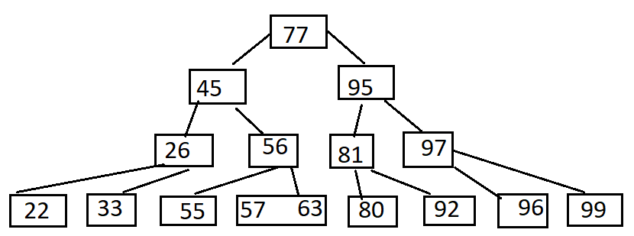

**[Solution]**

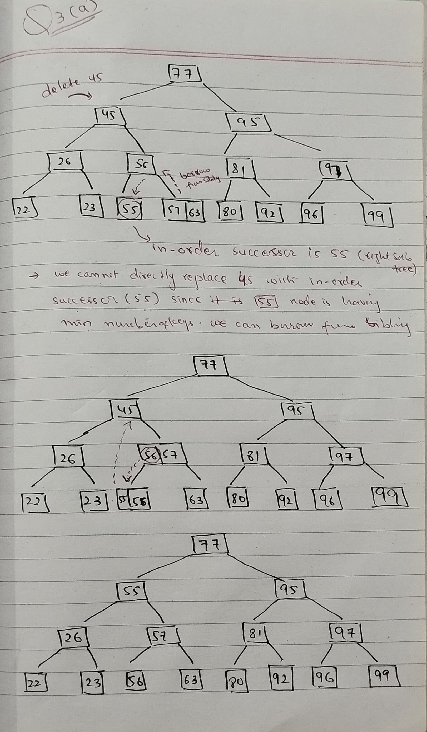

1. Balance the following tree using AVL rotations.

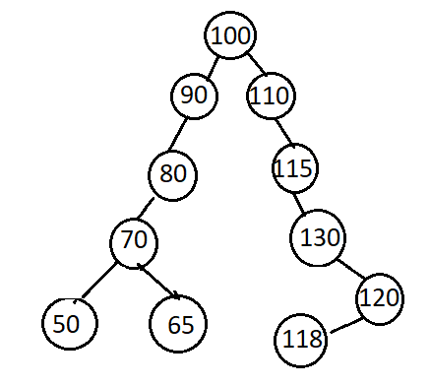

**[Solution]**

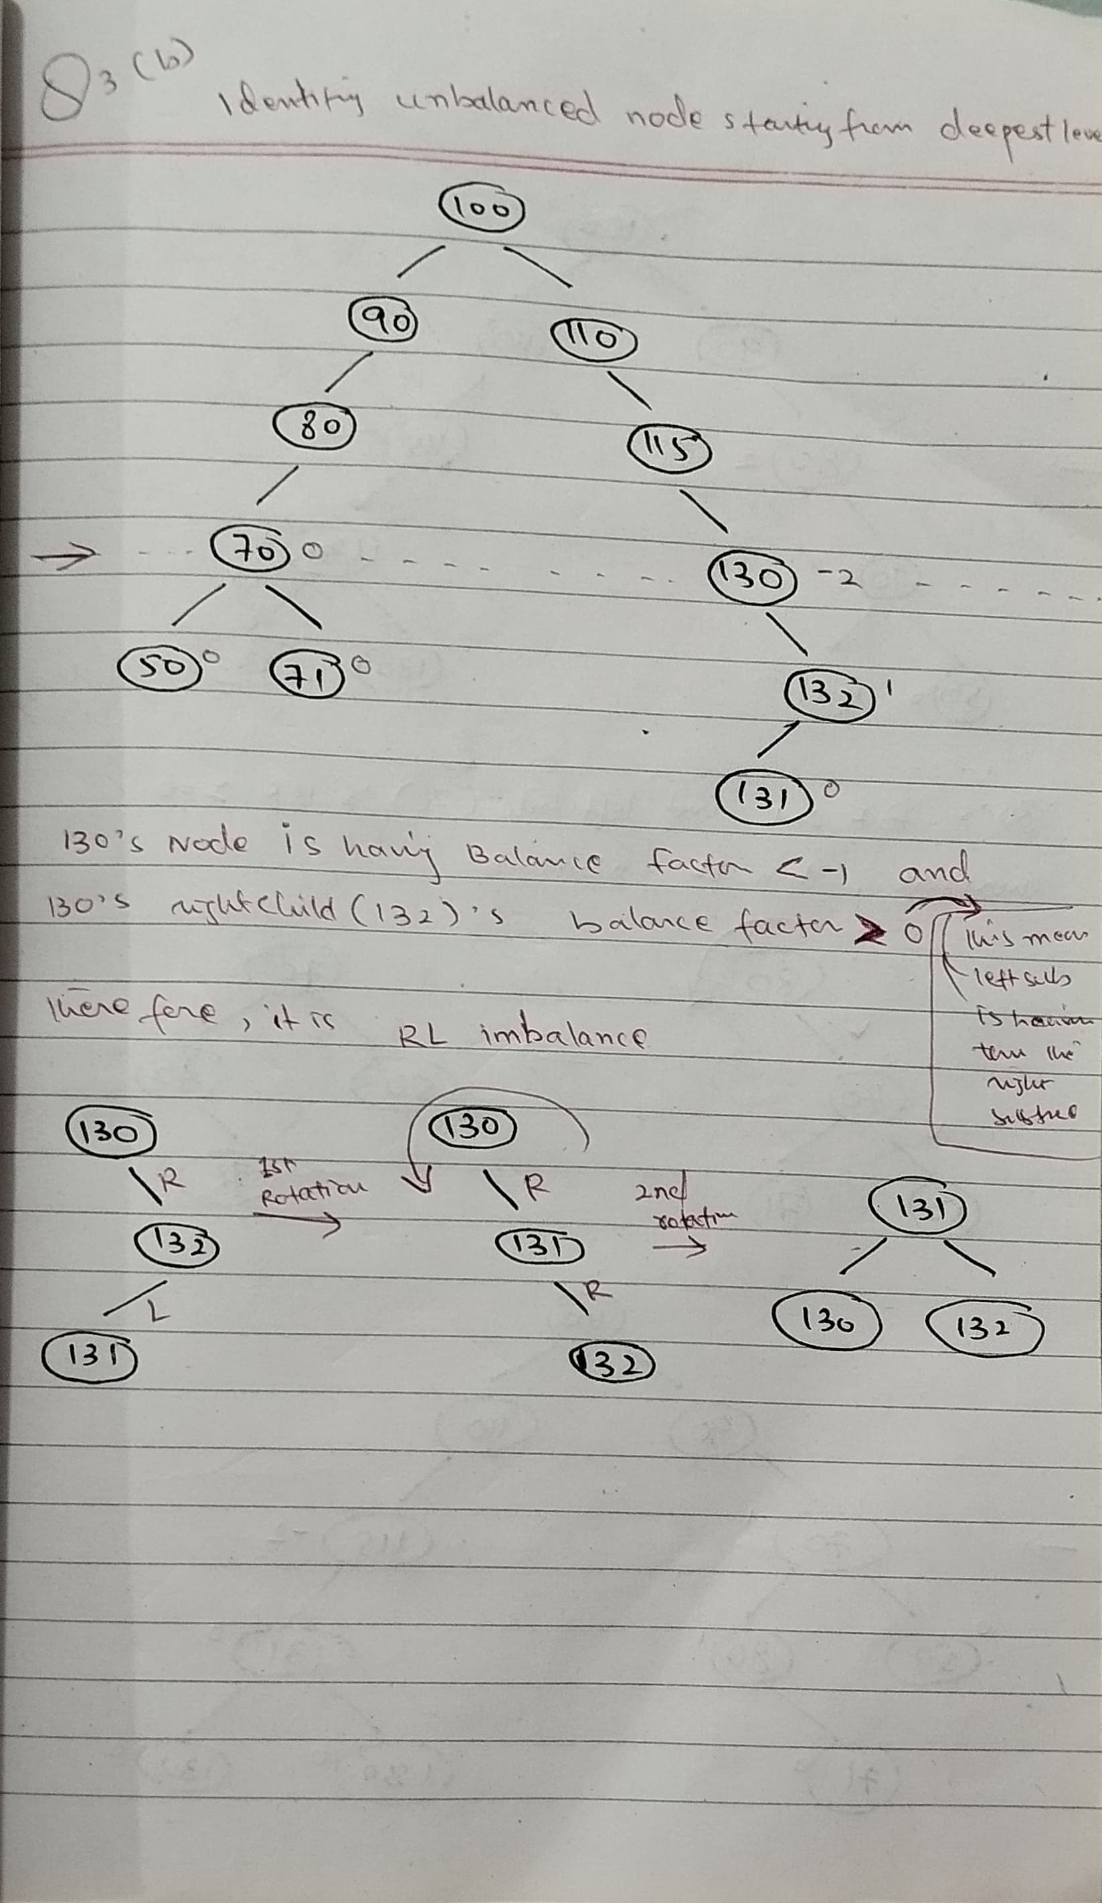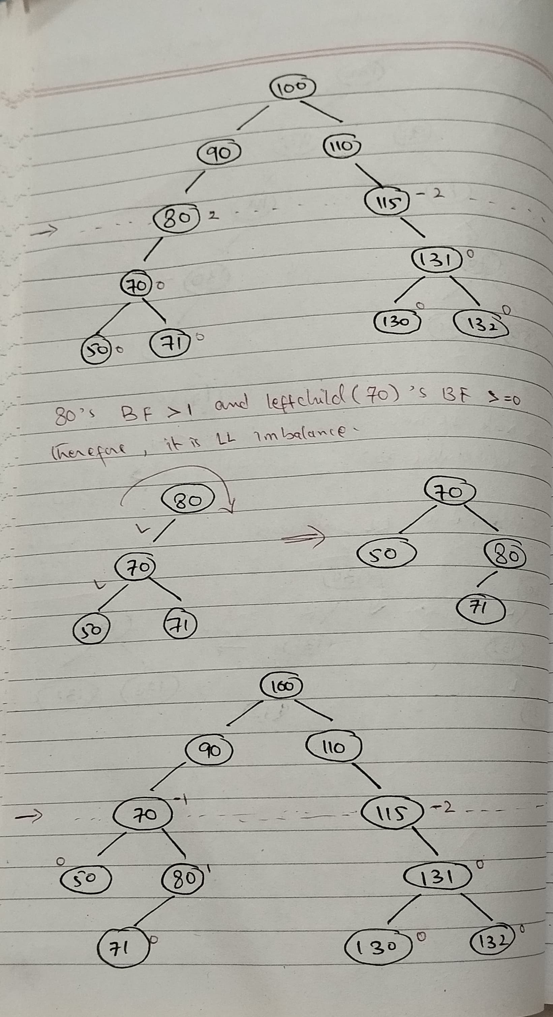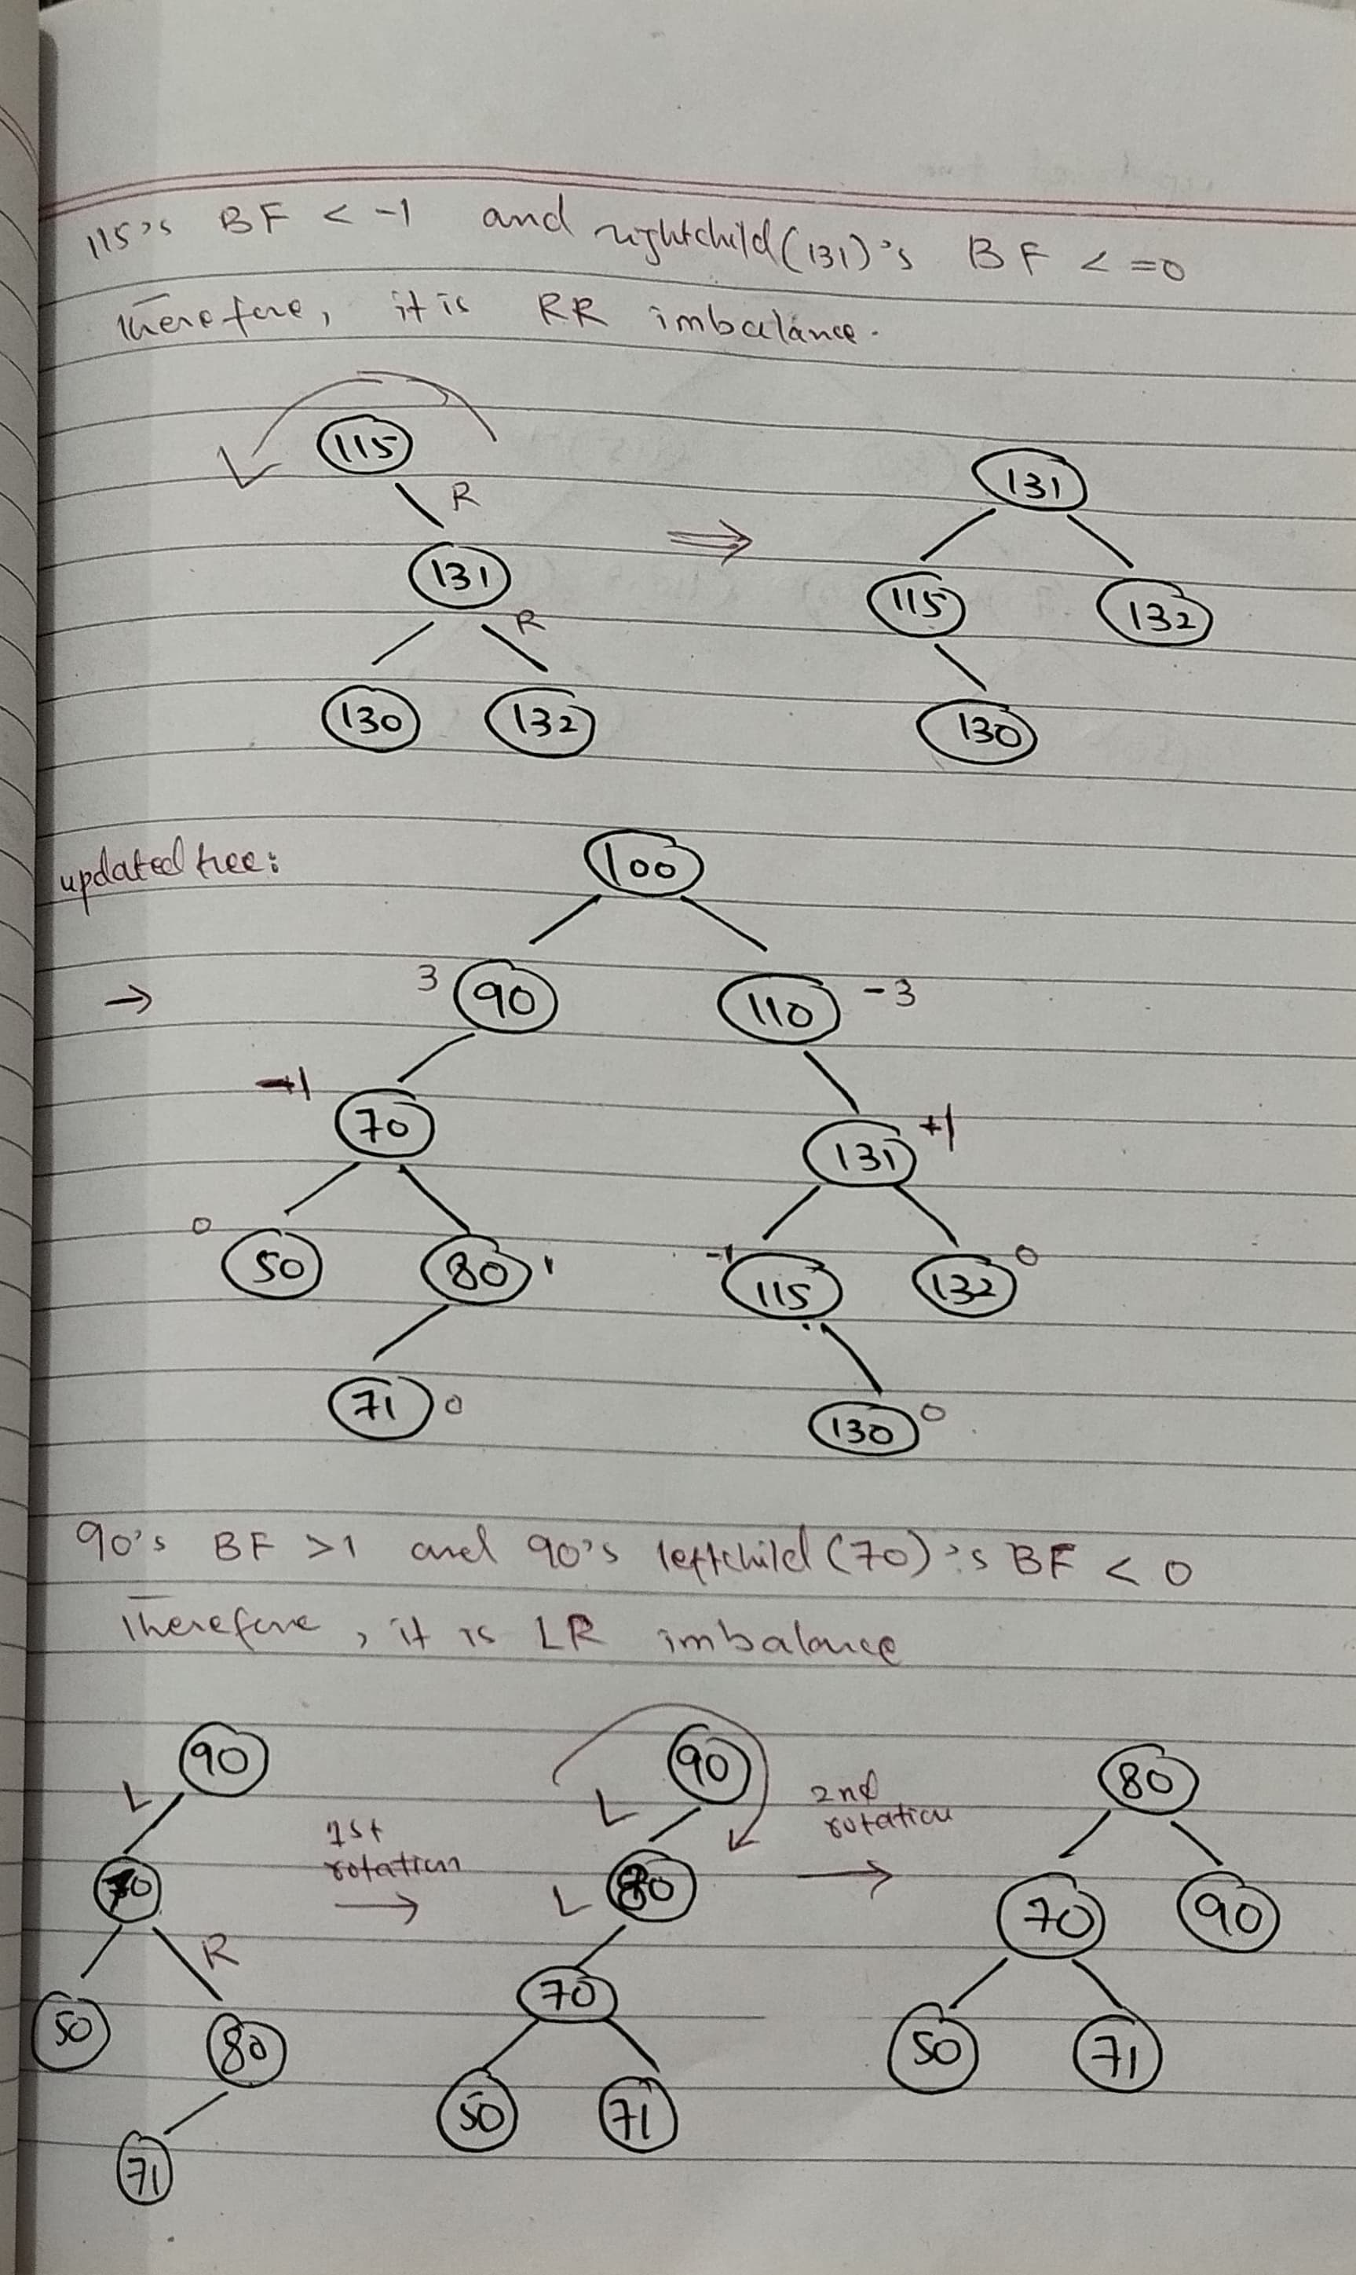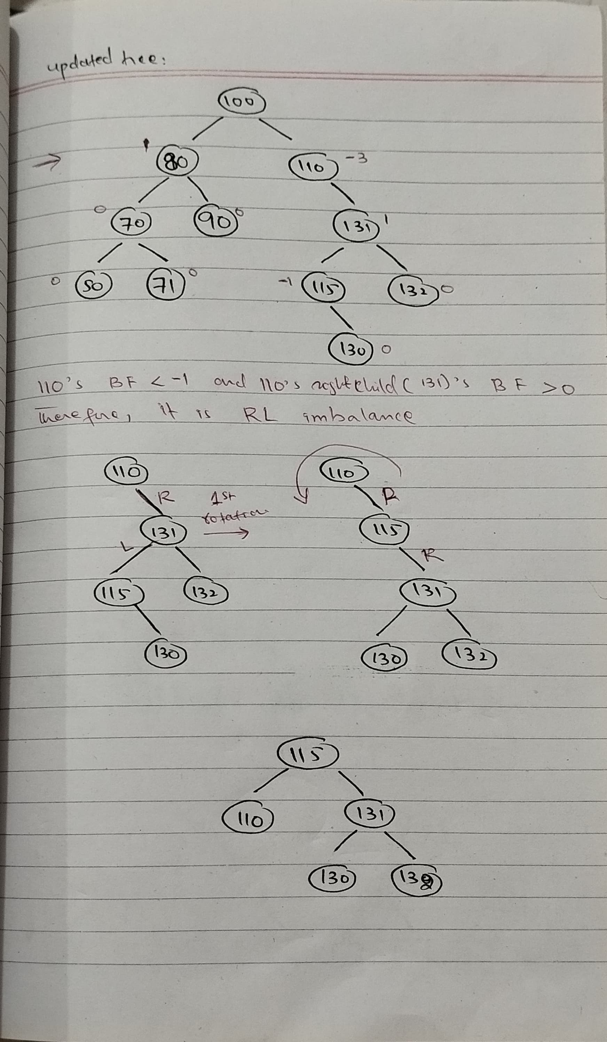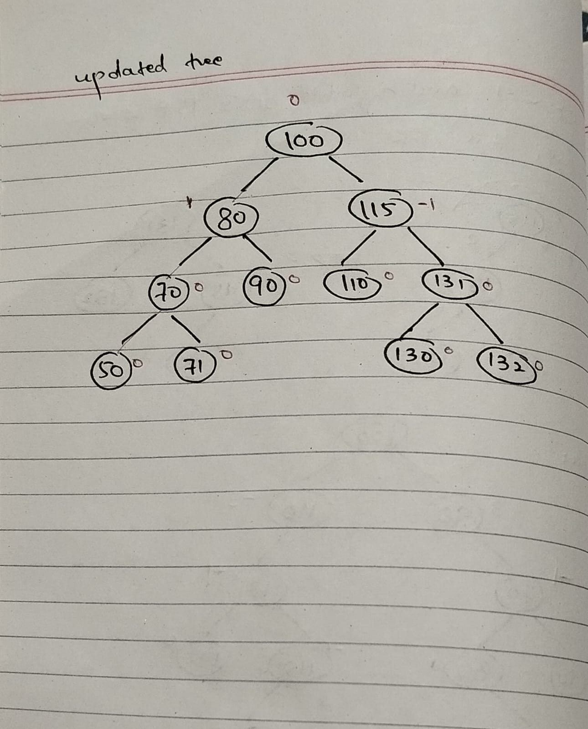

1. Using a B-tree of order m=5, show step by step insertion for the following sequence:

**IDs: 10, 20, 30, 40, 50, 60, 70, 80, 90, 100.**

**[Solution]**

